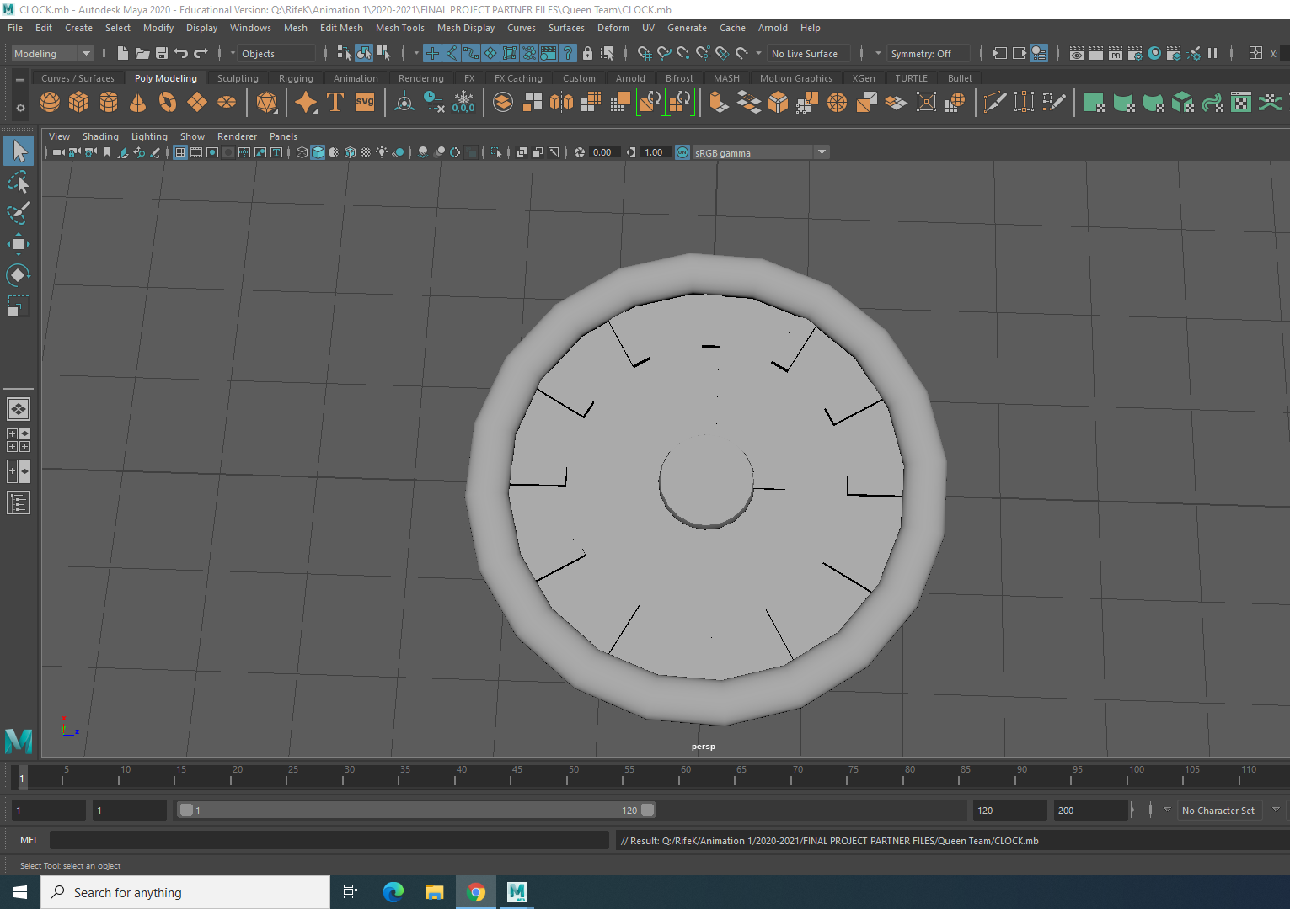
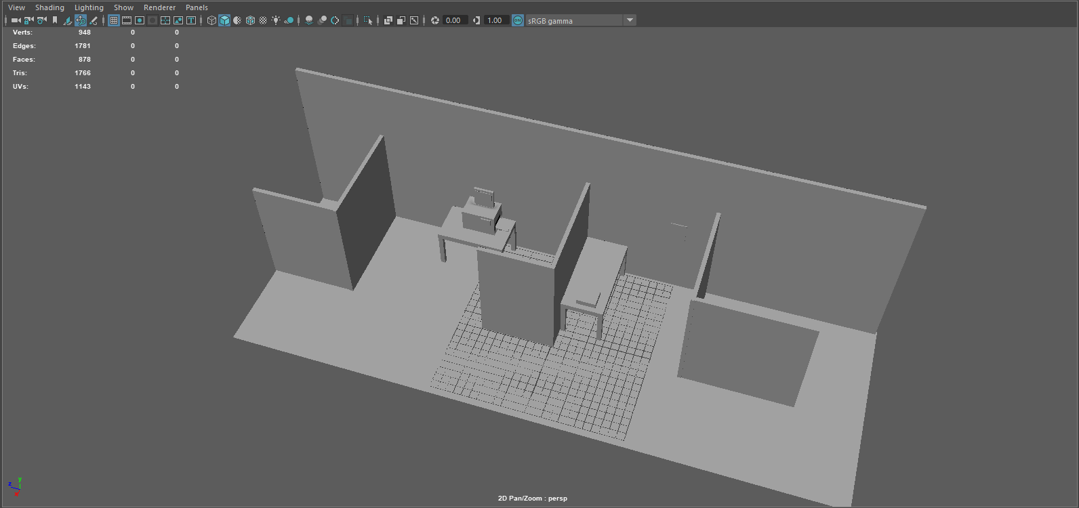
We have worked on a lot so far, here’s a bit we have done! For Madison, she has been working on the office, and accepting or denying ideas. She’s done the base for the office, and has started texturing the office while Mitchell and Jacob have been working on different objects for the office. Jacob has been working on the biggest part for the animation, the Man. He’s been adding a lot of detail, and the character has come out really well. Finally, for Mitchell, he’s been working on making different objects for the office. We have been communicating a lot with this assignment, always sharing the ideas we have at any possible chance we get.

